Progress Document #5

This week the team met and planned the design of the website. We decided that we want the website to be very simple to use. With that said the website will include the following 3 tabs:

* The first Tab is the “registration Tab”.
  + In this Tab, the homeless shelters will be able to log in and post items they need in order for people to donate.
* The second tab will be the “Home” Tab.
  + This tab will allow the user to understand the purpose of our website and what we are trying to accomplish.
* The Third tab will be the “Find charity” tab.
  + This tab will utilize a google map API and allow the user to search for homeless shelters near them.
  + The user will be able to locate where the actual homeless shelter is on the map

Group Progress:

Izzat Hasan: Worked on the front-end design of the website

Alex Hartlab: researched and found APIs of homeless shelters' Zip codes

Soren: researched ways we can implement google maps in the website.

**This is the inspiration that we came up with as far as the google maps api**

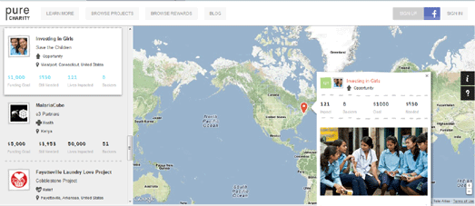

Goal for next week:

**Continue writing code and implementing the front end design of the website.**